

Advertiser Funded Programming

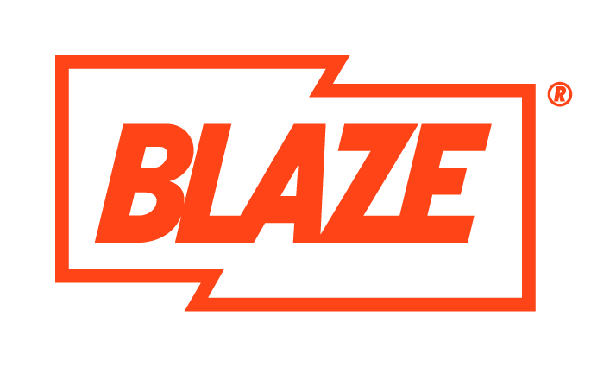

Advertiser Funded Programming, often referred to as…



Branded content



Linear AFP


Producer Led AFP

What is “Linear Advertiser Funded Programming”? An Advertiser pays 50% or more of the total production costs of a longform programme or series, in exchange for key rights.

What is a Producer Led AFP? A longform programme or series that’s editorially approved by the Broadcaster, Commissioners and Schedulers with Brand funding secured by the Producer (or a third-party agent) outside of the Broadcaster

AFPs are considered Sponsored programmes, so the same rules apply for ‘normal’ sponsorship arrangements.

Industry Trends:

- Brands recognise that audiences like to skip ads so want their presence inside programmes, not just around them
- Production companies are actively pitching to brands or ad agencies as they look for alternative funding
- Co-funding is common and the short fall is usually met by the broadcaster or streamer
- Promos might include sponsorship credits or online extensions

Key examples of Ad funded programmes:

CH4: Jamie’s Air Fryer series
- CH4, Co-funded by Tefal
- On-screen warning at start: “This programme has product placement”
- Prominent opening advert-style sequence featuring a Tefal air fryer, with a branded ‘P’ burnt into food
- Ident: “Jamie’s Air Fryer Meals with Tefal”
- Tefal air fryer and pan used throughout the programme, but verbal commentary remained generic and unbranded
- Illustrates Ofcom’s more pragmatic, commercially realistic approach to product placement rules



Cooking with the Stars – ITV
- M&S co-developed the format with South Shore to appeal to families
- ITV picked up the idea after M&S & South Shore created the IP.
- M&S wanted to reinforce that they offer more than prepared meals, hence this format using ingredients to ‘cook from scratch’
- Show featured M&S’s high-quality range of fresh ingredients & ‘scratch cook essentials’
- First time M&S Food worked with an indie to jointly develop a TV show

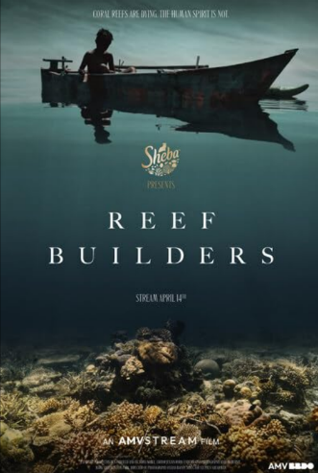

Reef Builders (Sheba Cat Food & AMV)
- Driven by Sheba CEO and their passion for coral reef restoration.
- Ofcom rule: a sponsor cannot fund a programme about its own product or direct brand interest. The subject had a clear editorial, public-interest purpose.
- Sheba branding not involved editorially.

What’s the difference between ad funded and sponsored?

Ad Funded Programme | Sponsored programme
Brand helps pay for the programme itself (some or all of the production budget). | Programme is already commissioned/paid for by the broadcaster.
Brand is involved earlier – can help shape the idea, format or access (within Ofcom rules). | Brand buys association around it, mainly via sponsorship credits/idents before/after and around the show.
Brand is often more deeply woven in (e.g. title, integrations, product placement as allowed). | Very little or no say in the content of the programme itself.
Needs clear editorial control by the broadcaster and sponsorship signalling | Usually no or minimal in-programme presence of the brand (unless it’s also doing product placement under separate rules).

Key differences from normal programming:
- The brand pays (some or all) of the production costs in return for some form of promotion.
- The brand’s involvement is clearer and more visible than usual.
- The content can’t be about the brand, but it can include its products.
- If the sponsoring brand appears in the programme, this is usually treated as product placement, so PP rules apply (eg must be editorially justified and not unduly prominent).
- The broadcaster must keep full editorial control, and this must be obvious on screen. The funder must not influence content or scheduling in a way that affects editorial independence, and the commercial relationship must be clear.
- AFPs must follow sponsorship signalling rules. Credits can be:
  - Standalone sponsorship idents next to the programme, or
  - Credits within the programme (e.g. in titles or part bumpers).
The second option is more common for AFPs, where the brand may be in the show title, but this is subject to extra rules.

Compliance for AFPs

Some genres of programming cannot be sponsored, some products cannot sponsor and others may have scheduling restrictions.

News, Current Affairs, Political and Consumer Advice programming cannot be funded/sponsored.

Restricted advertisers e.g. food and drinks high in fat, salt and sugar (HFSS), alcohol, gambling, medicinal products, cigarettes, infant formula - can fund programmes but cannot have product placement. There may also be restrictions on times of day, depending on the brand.

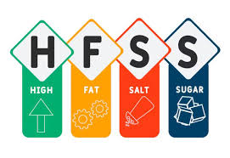

Programmes must follow Ofcom rules and AFPs are subject to the same Ofcom rules as Sponsorship. A brand funder must be credited onscreen to let viewers know they’ve been involved. This is done through sponsorship idents. Click here to view full Section 9 from the Ofcom code for further details

A Brand funder can product place within the same editorial, provided it’s in a non promotional way and is editorially justified – product placement rules apply.

Compliance will need to discuss with Programming the various options for naming and signalling to decide which works best for each programme on a case-by-case basis. It’s important for editorial, commissioners, compliance and advertising to collaborate closely.

To be agreed with compliance before an AFP deal is done:
- Programme format & script outline
- Cast outline including presenter
- Sponsorship credits

Specific channel advice: History, CI and Blaze – All channels are treated the same. However, we need to be very careful with any brands we work with due to sensitivity reasons. I.e. A knife company sponsoring a programme about victims of knife crime or a disreputable tourism company that could risk brand reputation and produce an inflammatory response from viewers would be a hard no.

Compliance Timeline
To approve a pitch or assets we ask for a three day turnaround on feedback, however, we always aim to get back to you within 24 hours, depending on other priorities. Feedback can take longer, depending on the client.

OFCOM Rules:
AFPs must comply with the Ofcom Broadcasting Code and the BCAP (Advertising) Code, which place limits on how brands can be involved.

1. No promotional content
A brand can fund a programme, but:
- The programme cannot promote the brand, product, or service.
- There must be no calls to action (“Go buy…”, “Visit…”).
- You can’t give the brand undue prominence (too many shots, too positive, too integrated).

2. Editorial independence must be protected
This is a major rule:
- The broadcaster and producer must retain full editorial control.
- The sponsor cannot dictate script, storylines, casting, or outcomes.
- The programme has to feel editorial, not advertorial.

3. Mandatory transparency
Programmes must:
- Carry sponsorship credits (e.g., “This programme is sponsored by…”, “brought to you by…”, “in association with…”. Can also be more creative “powered by…” or ‘driven by…”).
- Follow strict rules on where and how those credits appear.

4. Content suitability
Some brands cannot fund programmes in certain genres:
- Alcohol brands cannot sponsor children’s content.
- High fat/salt/sugar brands face restrictions.

5. No “product placement by the back door”
- An AFP does not automatically allow product placement. Even though AFPs involve funding from brands, Ofcom treats product placement separately and with its own restrictions.

What’s Allowed vs Not Allowed

Area | Allowed | Not Allowed
Brand Involvement | Funding the programme; giving general thematic input | Dictating editorial content, storylines, contributors, outcomes
Brand Visibility | Occasional, natural, incidental presence | Shots engineered to feature the product; lingering close-ups; logo focus
Editorial Control | Producer + broadcaster fully in charge | Brand approval over edits, scripts, or narrative decisions
Messaging | Neutral references; context-relevant mentions | Promotional claims (“best”, “cheapest”, “must-have”), calls to action
Sponsorship Credits | Standard credit at start/end | Credits that feel like an advert, make claims, or include calls to action
Product Placement | Only if separately approved AND declared | Sneaking in product shots via AFP funding
Brand Categories | Most brands OK | HFSS food in children’s content, alcohol with minors, other restricted categories

Examples: Compliant vs Non-Compliant AFPs

Compliant AFPs | Non-Compliant AFPs
M&S helps fund “Cooking With the Stars” because the format exists regardless of M&S | A DIY show where the brand funds the programme and the edit includes repeated close-ups of their tools
Logo appears in sponsorship bumpers | A fitness brand funds a show and insists contributors must use their equipment
Contestants may use M&S ingredients only if it’s editorially justified and not singled out as better | A fashion brand funds a makeover show and the presenter keeps referencing how great their clothes are
Brand has zero say in casting or storylines | These would be considered undue prominence or a breach of editorial independence.

What’s in it for the brand?

Their 5 key rights:

- Sponsorship Idents aka credits or bumpers:
These sit around the editorial to make it clear to the viewer that a programme has been made in partnership with a Brand e.g., “Brought to you by”, “in partnership with”. ​ Must be approved by Compliance. ​
Usually created by the Brand Creative Agency

- Co-Branded Title Card: Brand logo appears for 3 secs minimum at the start and end of each part of the programme, during the opening sequence – reinforces the same association line as in the Sponsorship idents. Cannot include a brand strap line eg ‘Every little helps’ – Tesco.
Usually created by the Producer as part of the graphics package

- Product Placement: Brand products/services integrated into the editorial – verbal or visual. Must follow Ofcom rules and not be promotional or unduly prominent). ​
Prohibited products: Alcoholic drinks, HFSS, gambling, infant formula, medicinal products, cigarette lighters, papers or smoking pipes, any product, service or trademark that is no allowed to be advertised on TV.
OFCOM - guidance notes for commercial refs in TV programming

- Programme Assets and Usage:
Assets: Brands can use up to 6 minutes of clips and 5 publicity stills per episode on their platforms
Usage: can only be on their platforms, not a third party or additional partners / individuals. Assets must push viewers to the channel e.g. “Watch live or stream on…”.
Brands must share media plan & posting schedule (including socials) for review prior to launch
The assets and usage must be approved by Hearst compliance

- Clickable Brand Logo: A logo on the programme’s streaming page linking to the brand’s website. ​

Key Contacts:

Sebrina Zeki, Director of Compliance: Sebrina.zeki@hearstnetworks.com

Julie Brown, Senior Compliance Manager: Julie.brown@hearstnetworks.com

Molly Storey, Senior Compliance Exec: Molly.storey@hearstnetworks.com

Commissioning Editors and Ad Sales must be kept in the loop throughout the process

